PITHAPUR RAJAH’S GOVERNMENT COLLEGE - KAKINADA

An outcome based Autonomous institution
Reaccredited with ‘B⁺⁺’ Grade by NAAC: ISO 9001: 2015 certified Institution (Affiliated to Adikavi Nannaya University)

UG Single Major program

BBA

(Healthcare Management)

with
Human Resource Management
(Minor)


BOARD OF STUDIES - 2025-26
DEPARTMENT OF COMMERCE & MANAGEMENT STUDIES

Profile of the Department
The Commerce Department was established in the year 1956 under the aegis of Sri EV Narasimha Murthy and followed by big names in the academia such as Sri R Krishna Murthy and currently headed by Dr K Lakshmana Rao. it is the single largest individual department in the college with 670 students and 5 programs. The department initially offered general UG program in Commerce (B COM) in both Telugu and English media and expanded to offer other Commerce UG programs in combination with interdisciplinary subjects such as B COM CA in 2012 and B COM CECS in 2013. The Department had started PG program in Commerce (M COM) in the year 2014 with Accounting and Taxation specialization. The department entered in management education by starting a UG program in management (BBA – Digital Marketing) in 2020, (BBA - General) in 2025 and B. Com (BFSI) in 2025 thus making it a truly interdisciplinary department.
To reflect this diversity in the courses offered by the department, the name of the department was changed as Department of Commerce and Management Studies. The students of the Department have brought laurels in the fields of Accounting, Management, Taxation, Public Services, Sports and Creative Arts. The alumni comprise of several eminent personalities. The Department had also produced considerable number of Charted Accountants as well as Company Secretaries.
The Department is currently served by 13 dedicated and qualified faculty members. Five Doctorates and six members qualified in UGC-NET/SET and six dual PG holders. The department is recognized as a Research Centre of Adikavi Nannaya University, Rajahmundry in the subject of Commerce. The faculty members have to their credit more than 80 research articles published in various referred National and International journals and more than 5 published text books. The faculty members keep abreast to the emerging changes by attending faculty development programs, refresher courses, both online and offline.
Faculty design the curriculum and transact the curriculum in a well-planned manner using a range of suitable methods of learning. In addition to that Workshops and Seminars are being organized at National and International levels. Projects and internships also from an integral part of the curriculum. The students comprise of more than 70% from Socially and Economically challenged groups and more than 45% are women. Thus, making it a truly diversified students’ community. The Department has been aiding these groups and upholding the pillars of universal education viz. Equity, Access and Quality.
Unique Features:
- Two Alumni are the faculty members.
- Five Doctorates as faculty members.
- Seven M. Phil holders in the Department.
- Six dual PG(MBA) holders in the Department.
- Six NET/SET qualified faculty in the Department.

Combinations-Courses offered:
B. Com Single Major
- B. Com - General - Minor with Computer Applications
- B. Com - Tax Practice and Procedures - Minor with Taxation
- B. Com - Computer Application - Minor with Taxation
- B. Com - Banking, Financial services and Insurance
- BBA - Digital Marketing- Minor with Human Resource Management
- BBA - General - Minor with Finance
- BBA - Health Care Management - Minor with Human Resource Management

Certificate Courses:
- Start-up Management
- MSMEM
- 21st century skills
- Cyber laws
- GST- E-filing
- Insurance
- Retail marketing
- Logistics Management
- Risk management
- Financial planning
- Healthcare Information Management
These Courses are open to students of all Commerce students. The Department previously offered the foundation course of Entrepreneurship to all the 2nd year students of the college as per the previous curriculum.
Participation of the department in the courses offered by another department:

- Marketing Skills
- Retail Marketing
- Logistics and supply chain Management
- Insurance Promotion
- Entrepreneurship
- Project Management.

The department currently offering PG program in Commerce i.e. M.Com. (Accounting and Taxation) since 2012 – 13. Currently the PG program of the college also got the autonomous status.

STAFF PROFILE
Staff Particulars:
The department consists of 13 staff members (Regular -3 +1, Contract – 4 and Guest Faculty – 6) of which Five Members process Ph.D, seven members process M. Phil and Six Members possess NET/APSET academically enriching the department
Particulars of the Lecturers
S.N  o | Name Of The Faculty | Qualification | Designation | Experience
1 | Dr.K.LAKSHMANA RAO | M.Com.,MBA.,APSET.,PGDC  A.,M.Phil.,Ph.D.,PDF | HOD  &  LECTURER | 13 YEARS
2 | Dr.J.PANDURANGA RAO | M.Com.,MBA.,NET.,APSET., M.Phil.,Ph.D., | LECTURER | 25 YEARS
3 | Dr.K.NAGESWARA RAO | M.Com.,NET.,M.Phil.,Ph.D., | LECTURER | 27 YEARS
4 | SRI CH BALAJI | M.Com.,MBA.,APSET.,M.Phil (Ph.D) | LECTURER | 23 YEARS
5 | SRI.D.S.MADHU PRASAD | M.Com.,MBA.,APSET.,M.Phi  l.,MA.,LLB.,(Ph.D) | LECTURER | 24 YEARS
6 | G.S.R.S.G.NOOKA RAJU | M.Com.,MBA.,M.Phil.,Ph.D | LECTURER | 23 YEARS
7 | Smt. B.CHINNARI | M.Com., (Accounting) | LECTURER | 20 YEARS
8 | Dr.D.VENKATESWARA RAO | M.Com., APSET.,M.Phil.,Ph.D | LECTURER | 7 YEARS
9 | KUM. P. SANGHAVI | M.SC Computers | LECTURER | 2 YEARS
10 | SMT. V ASHA JYOTHI | MBA | LECTURER | 3 YEARS
11 | KUM. P MOUNIKA | B.Sc Nursing., MBA ( HCM) | LECTURER | 6 YEARS
12 | KUM M PAVANI | M.Com ( Banking and Finance ) | LECTURER | 3 YEARS

FACILITIES OF THE DEPARTMENT

- A separate computer lab established for the B.Com (CA) and BBA (DM) students to enable the students for application-oriented delivery of instruction in the specialized courses.
- LCD Projectors with a Computer and peripherals are provided as Teaching Learning Resources.
- Wireless internet facility is available in the Department to tech academics in ICT mod
- The Department is providing Business News Papers, Magazines, Journals and online Resources related to the subjects to all the students.
- The department has been running a strong Reference Section with 200+ Books and Online Resources for faculty reference and library consultation.
- The Department housing 13 lecture halls and a staff room in two blocks i.e. old commerce block – 6 and New Commerce block – 7 halls with all facilities provided for effective teaching.
- The department is providing the printed material and e-content i.e. PPT, Video in various Subjects for Effective learning. The department engaged in online teaching during the pandemic time through utilizing the Google suite for Education Apps (Google Meet, Google Classroom and Google Drive etc.)
- The Department is encouraging the students in various CO-Curricular and extracurricular activities i.e. attending Seminars, Quiz, Group Discussions, Workshops, Fests, Yoga, Sports and Games.
- The Department is extending the Financial Support to the poor students under the banner of Helping Hands.
- The Department is encouraging the alumni to provide academic and financial assistance to students.
- The Department is encouraging the students to involve in student Research Projects through Subject related Surveys, Field trips and interviewing eminent people in district to gain from their experience.
- The Department is Organizing Industrial in every Year.

P.R COLLEGE (A) KAKINADA
DEPARTMENT OF COMMERCE AND MANAGEMENT STUDIES
BOARD OF STUDIES of UG
August Body for Board of Studies – 2025-26

S. No | Name of the Nominee | Designation
1 | Dr K. Lakshmana Rao | Chairman & HOD- DCMS
2 | Dr G Arun Kumar | University Nominee – UG & Assistant Professor  Dr. VSK Govt. College - Vizag
3 | Dr. G Srinivasa Rao | University Nominee – PG & Assistant Professor  Dr. VSK Govt. College - Vizag
4 | Dr E. Appa Rao | Subject Expert & Asst. Professor  DCMS – MSN Campus – AKNU, Kakinada
5 | Dr L Madhu Kumar | Subject Expert & Asst. Professor  DCMS – MSN Campus – AKNU, Kakinada.
6 | Dr B Charwak | Subject Expert & Asst. Professor  SMS – JNTU – K - Kakinada.
7 | Sri M Srinivasu | Subject Expert - GDC - Tuni
9 | Dr P P Chandra Bose | Subject Expert  HOD Commerce – GDC - Razole
10 | Dr P Shanmukha Rao | Subject Expert (Digital Marketing)  Associate Professor – Arts College (A) RJY
11 | Sri S. Rama Krishna Reddy | Industrialist
12 | Sri.P. Venkata Krishna | Student Alumni & Educationalist
13 | Dr J.Panduranga Rao | Member
14 | Dr.K.Nageswara Rao | Member
15 | Sri. D.S.Madhu Prasad | Member
16 | Sri.G.S.R.S.G Nooka Raju | Member
17 | Smt.B.Chinnari | Member
18 | Dr. Venkateshwara Rao | Member
19 | Kum P Mounika | Member
20 | Smt. V Asha Jyothi | Member
21 | Kum P Sanghavi | Member
22 | Ch Vinod | Student Member (HCM)
23 | S Bharghavi | Student Member (DM)
24 | Y Tanuja | Student Member (CA)
25 | B Pavan | Student Member (DM)
26 | Ashok | Student Member (GEN)
27 | Sai Chaitanya | Student Member (TPP)
28 | - Swaroop | Student Member (CA)

BEST PRACTICES OF THE DEPARTMENT
- A unique platform of Charted Accountants, Registered Tax Practioners and Independent Professional Accounts has been credited in the name of BIZ Coach to make the students familiar with the latest developments in Accounting, Taxation and general business-related aspects. This platform is aimed at bringing and linking the various minds at work to academic activity. Students are given hands on practice of accounting and tax procedures. Students can benefit immensely in terms of experience and thought-provoking guidance by the professionals.
- The Department has carved out a unique and one of its kind, Centre for Entrepreneurship and Incubation in the college. This type of Centre is aimed at the imbibing and developing the entrepreneurial skills among the students. This Centre is strengthened the collaboration with the SETRAJ and DIC, East Godavari in terms of mutual cooperation for capacity building and handholding in the entrepreneurship development. Students benefit from the guidance and technical assistance by the Government agencies and plan for the venturing into business.
- The Department has been organizing interaction sessions for the students with the Alumni particularly recent outgoing students in the matters of career choice, job markets and higher education etc. Students to benefit from the experiences of these outgoing students.
- The Departments running a companion group through WhatsApp for all the students to answer their queries in different subject domains. Students can ask questions in this forum and all the lecturers are part of this initiative and wide array of possibilities are opened up for students in the quest for learning
- The Department of Commerce has been inducting 10% to 20% additional inputs in the form of application concepts, case studies etc. in addition to APSCHE Syllabus and guidelines.
- Organizing the Field Visits, Seminars and Guest Lectures to impart Quality Education.
- The department is encouraging the students to involve in student study projects duly incorporating subject related surveys. These study projects based on the latest trends in the business environment.
- The Payment of Examination Fee and Tuition Fee to Poor and Needy students by the Faculty Members.
- Establishment of Commerce Students Welfare Association.
- Providing immediate Medical Aid to the students in case of Emergency.

AGENDA FOR THE MEETING 2025-26

Discussion on the Action Taken Report for the Board of Studies (BoS) 2025-26.

Adoption of the single-major system as mandated by the Andhra Pradesh State Council of Higher Education (APSHE) and the Commissionerate of Collegiate Education under the National Education Policy (NEP) 2020.

The Department of Commerce and Management Studies offers the following single-major programs and along with Minors: B.Com. (General with Computer Applications), B.Com. (Tax Procedures and Practice with Computer Applications), B.Com. (Computer Applications with taxation), BBA (Digital Marketing with Human Resource Management), and BBA (HCM with Human Resource Management). Starting this academic year, two new programs are being introduced BBA (General with Finance ) and B.Com. (BFSI).

Implementation of the B.Com. (Honours) General program based on student enrolment.

Approval of Program Outcomes, Program-Specific Outcomes, and Course Outcomes for the single-major programs 3B.Com. (General), B.Com. (Tax Procedures and Practice), B.Com. (Computer Applications), BBA (Digital Marketing), BBA (General), BBA (Healthcare Management), and B.Com. (BFSI).

Approval of blueprints, model question papers, and question banks for all undergraduate and honours programs, aligned with Bloom’s Taxonomy.

Approval of the evaluation scheme for internal and external assessments for I, II, and III years and the honours program, following a 50:50 pattern.

Approval of the activity-wise breakup of Continuous Internal Assessment (CIA) for I, II, and III years and the honours program.

Inclusion of additional inputs for each course to enhance students’ knowledge and skills.

Implementation of a Community Service Project for I-year students after the II semester.

Provision of internships, apprenticeships, or on-the-job training for II-year and III-year students.

Approval of the revised panel of question paper setters and examiners.

Approval of extra credits for completion of free or paid online courses, including MOOCs and SWAYAM.

Offering of ten certificate courses open to students of all groups: Start-up Management, MSME Management, 21st Century Skills, Cyber Laws, GST E-Filing, Insurance, Retail Marketing, Logistics Management, Risk Management, and Financial Planning & Healthcare Information Management. These courses equip students with diverse, industry-relevant skills, enhancing their employability and entrepreneurial capabilities across various sectors.

Approval of the Department’s Action Plan for 2025-26, including organizing seminars, workshops, training programs, webinars, and guest lectures.

For the academic year 2025–26, the first-year curriculum for all UG programs has been adopted as per the APSCHE guidelines.

Any other proposals with the permission of the Chair.

P.R. GOVERNMENT COLLEGE(A) – KAKINADA
SL.  NO | NAME OF THE FACULTY | NAME OF THE COLLEGE | Contact No. | E-mail ID
1 | P. V. V. Satyanarayana | Arts College – Rajahmundry | 9441133025 | vvsnarayana.pachimala@gcrjy.ac.in
2 | Dr. A. Alimelu Annapurna | Arts College – Rajahmundry | 8978737858 | behara.anu@gmail.com
3 | Dr. Shanmukha Rao Padala | Arts College – Rajahmundry | 9440323606 | drsrpadala@gmail.com
4 | Dr. B. Prathima | Arts College – Rajahmundry | 9494473995 | gdc.prathima@gmail.com
5 | V. Ramesh Krishna | Arts College – Rajahmundry | 9948474434 | rameshkrishna.v@gcrjy.ac.in
6 | B. Sujatha | Arts College – Rajahmundry | 9381024955 | satish4suji@gcrjy.ac.in
7 | M. Srinivasu | GDC – TUNI | 9492962264 | manepallisrinivasu30407@gmail.com
8 | P.V.K.M Aleena | GDC – TUNI | 8985945942
9 | Dr.G Srinivasa Rao | VSK College – Vizag | 9290812640 | qtsrinivas@gmail.com
10 | RAMESH DANTULURI | VSK College – Vizag | 9912378877 | hidrameshhi@gmail.com
11 | Dr. G. ARUN KUMAR | VSK College – Vizag | 9885423407 | arun9885423407@gmail.com
12 | Dr. D. MURALIDHAR | VSK College – Vizag | 8500657165 | muralib4u5@gmail.com
13 | G KARUNA SRI | SRR & CVR – Vijayawada | 9440181446 | karunags@gmail.com
14 | Dr. K. Naveena | SRR & CVR – Vijayawada | 8639729282 | naveenagdc@gmail.com
15 | K SRI GOURI SUCHARITHA | SRR & CVR – Vijayawada | 9393024477 | ksgsucharitha@gmail.com
16 | Dr. K. Sudhakara Rao | SRR & CVR – Vijayawada | 9849828840 | drksrao1@gmail.com
17 | Dr. M. Syam Babu | SRR & CVR – Vijayawada | 9030622876 | mukkusyam@gmail.com
18 | Dr. D. Ch. Appa Rao | SRR & CVR – Vijayawada | 9533055767 | drdchapparao@gmail.com
19 | P Durgeswari | YN College – Palakollu | 9121702721 | durgeswari16@gmail.com
20 | D Manmada Rao | YN College – Palakollu | 8074878227
21 | Sri B Venkata Ratnam | YN College – Palakollu | 9704628727 | ratnambezawada2@gmail.com
22 | Dr. U.Madhuri | DNR College – Bhimavaram | 9440946631 | madhuridattla@gmail.com
23 | Dr Sudhakara Reddy | GDC (W) – Gunturu | 8500221375
24 | Dr N A Francis Xavier | Andhra Loyola College- Vijayawada | 9440524321 | nafrancisxavier@gmail.com
25 | Dr B.Syam Sundar | Andhra Loyola College- Vijayawada | 9849313887 | drbsyamsundar@gmail.com
26 | Ms Nirmala Rani | Andhra Loyola College- Vijayawada | 8106998735 | nirmalarani1986@gmail.com
27 | Ms A. Sreelakshmi | ALC- Vijayawada | 7989628574 | asreelakshmi@ymail.com
28 | Dr. Ramalinga Prasad | ALC- Vijayawada | 9441746031 | ramalingaprasad2012@gmail.com
29 | Dr S Y Vishnu | MR College - Vizianagaram | 9963217252 | syvishnu444@gmail.com
30 | B Hari Krishna | MR College - Vizianagaram | 9396346494
31 | Dr. P Madhu | MR College - Vizianagaram | 9398066426 | madhupadala143@gmail.com
DEAPRTEMNT OF COMMERCE AND MANAGEMENT SUDIES (DCMS)
LIST OF EXAMINARS A.Y 2025-26

P.R. GOVERNMENT COLLEGE(A) - KAKINADA
DEAPRTEMNT OF COMMERCE AND MANAGEMENT STUDIES (DCMS) DEPARTMENTAL ACTION PLAN
FOR THE ACADEMIC YEAR 2025-26
SL.NO | MONTH | WEEK | PROGRMME
1 | JUNE | I | Internship /Apprenticeship
2 | JUNE | II | Reopening of college
3 | JUNE | III | CSP
4 | JULY | I | Charted Accountants Day (1st June )  I MID examination to III rd and I Semester
5 | JULY | II | Awareness programme (practice accounting as a profession)
6 | JULY | III | Banks Nationalization Day (19th July)
7 | JULY | Iv | Income Tax Day (24th July) , I- MID examination to I AND III SEMESTER
8 | AUG | I | COMMERCE DAY AND INDUCTION PROGRAMME
9 | AUG | II | UG ADMISSION
10 | AUG | III | Independence Day Celebrations (Aug 15)
 | AUG | Iv | Viva-Voce - I Semester and III Semester
12 | SEP | I | Teachers Day (5th Sept) Semester end examinations (I and III)
13 | SEP | II | Institute Mega career Counseling Programme All India Level Organized By DCMS and Charted Accountant Charter/ Company Secretory, Kakinada
 | SEP |  | I MID TO I, III SEMESTER
14 | SEP | III | Educational tour and industrial visit
15 | SEP | IV | National Seminar/Conference/ Workshop/FDP
16 | OCT | I | World Business Day (2nd Oct)
18 | OCT | III | II Mid Semester Examination
19 | OCT | Iv | Guest Lecture
20 | NOV | I | Guest Lecture
21 | NOV | II | Educational Tour
22 | NOV | III | Women Entrepreneurs Day (Nov 19th)
22 | NOV | IV | Invites Guest Lecture CSPTO I SEM
23 | DEC | I | AIDS DAY (Dec 1st)
24 | DEC | II | Human Rights Day (Dec-10th)
25 | DEC | III | Guest Lecture
26 | DEC | Iv | National Consumers Day (Dec24th)
27 | JAN | I | Guest Lecture
28 | JAN | II | PONGAL HOLIDAYS
29 | JAN | III | Parents meeting
30 | JAN | IV | Republic Day celebrations (Jan 26)
31 | FEB | I | Educational tour
 |  | IV | National Seminar/Conference/ Workshop/FDP

32 |  | II | Guest Lecture
33 |  | III | Management Day (Feb 21st)
34 |  | Iv | Talent Day
35 | MAR | I | Guest Lecture
36 | MAR | II | Alumni Meeting
37 | MAR | III | World Consumers Day (March 15)
38 | MAR | IV | WOMENS DAY (MARCH 08)
39 | APRIL | I | Guest Lecture
40 | APRIL | II | REMEDIAL CLASS
41 | APRIL | III | REMEDIAL CLASS
42 | APRIL | IV | SEM END Examinations

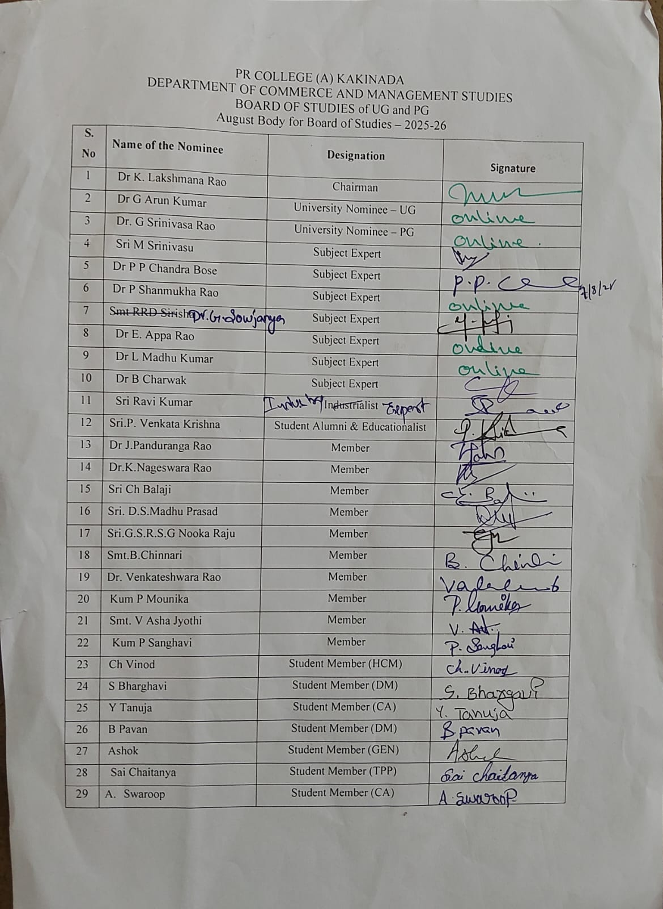

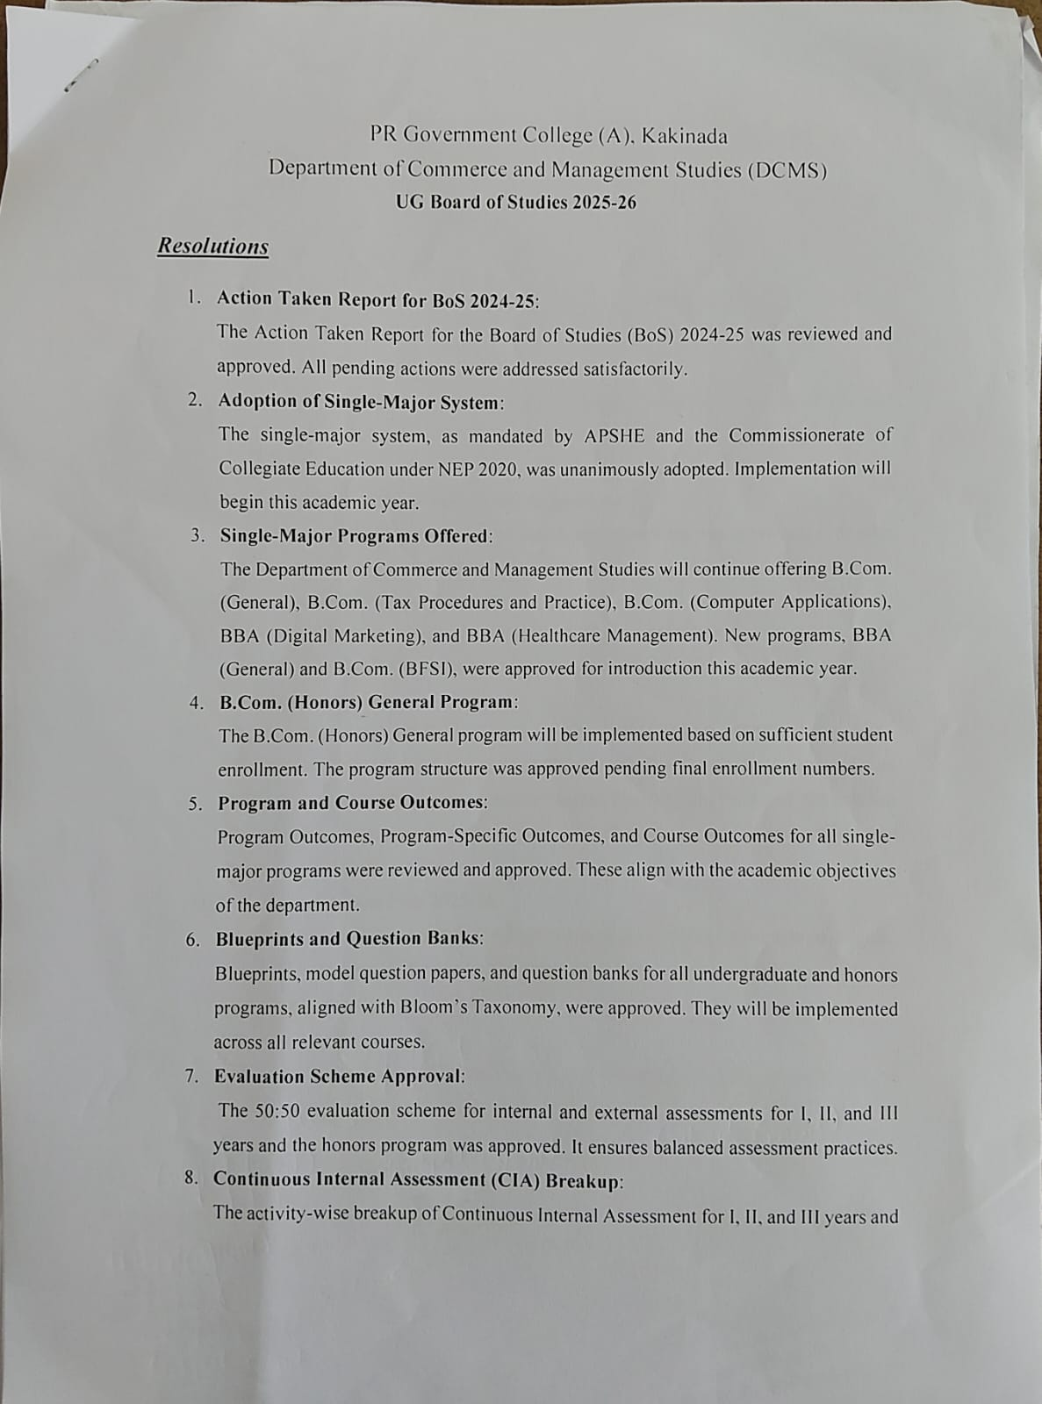

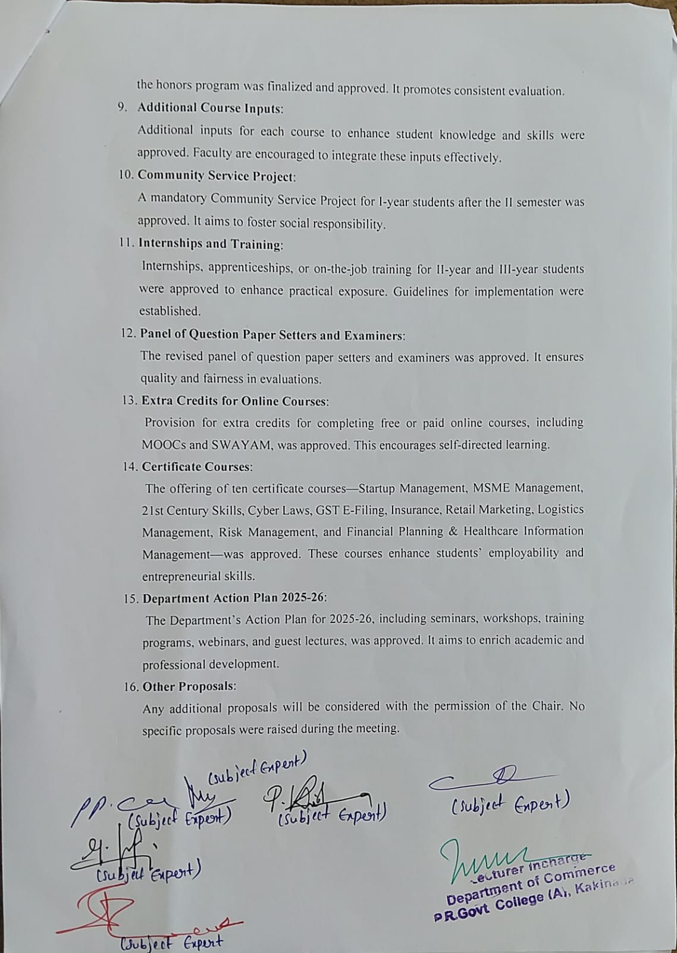

PR GOVERNMENT COLLEGE (A), KAKINADA
DEPARTMENT OF COMMERCE AND MANAGEMENT STUDIES

SCHEME OF EVALUATION FOR ALL UG PROGRAMS

Semester End Examination
Marks allocated – 50 Marks

- Model Question Papers as approved in the BOS Meeting for all the UG Programs under the Department of Commerce and Management Studies. Model Question Papers as per the APSCHE Guidelines.
- Paper setters to follow Bloom’s taxonomy in preparing questions to evaluate the student learning in various contexts.

Continuous Internal Assessment (CIA)
Standard Operating Procedure for the Internal Assessment (CIA) for I, II and III Year (All UG Programs)

Marks allocated – 50 Marks

S.No  . | Componen t | Distribution of  Marks
1 | Average of the following  - CIE I (after completion of 50% of syllabus) (25 marks with 50% weightage)  - CIE II (25 marks with 50% weightage) | 25
2 | Assignment | 5
3 | Seminar | 5
4 | Viva Voce | 3
5 | Clean & green and Attendance | 2
6 | Project Report | 10
TOTAL |  | 50

Component 1: Internal Evaluation (Mid Exams) (25 Marks)

Two Internal Mid Exams will be conducted 25 Marks each and scores will be averaged. Attendance to Mid Exams will as per the College procedures and will be conducted by the Controller of Examinations College wide.

Suggestive Question Paper Pattern for CIE I & CIE II (Based on Blooms Taxonomy):

Though the faculty concerned is empowered to adopt their own pattern for question paper, a general and suggestive model for question paper is given below based on Blooms Taxonomy.

S No of Question | Learning Objective | Marks
1 | Memory based (Remember) | 2
2 | Understand (Comprehension) | 2
3 | Application | 3
4 | Analysis | 3
5 | Evaluation | 5
6 | Evaluation | 5
7 | Creativity | 5
 | Total | 25 marks

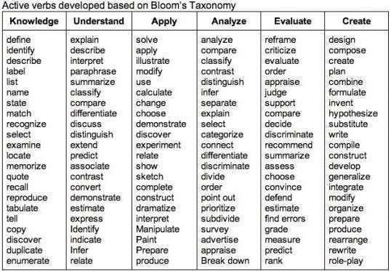
UG P.R. Government College (A), Kakinada – Dept. of Commerce

The active verbs used to frame the question based on Blooms Taxonomy is given below
for the convenience.

P.R. Government College (A), Kakinada – Dept. of Commerce
Component 1: Record (10 Marks)
Record work should be given to the students after the CIE II and well before the SEE. Faculty concerned has to inform the case scenarios for record preparation and each student or a group can be assigned with a case scenario. Students to come with their analysis neatly recorded. Record work can be conducted online also wherever possible.
Component 2: Viva ( 3 Marks)
For this component, the marks will be awarded to student, if he/she attends the Viva based on the case scenario given in Record preparation or any other topic related to latest trends in the subject area etc. Schedule of the Viva will be announced to students after completion of Record work. Marks will be awarded based on the subject clarity as well as communication clarity.

Component 3: Assignment (5 Marks)
One Assignment for each course must be submitted by a student in each semester. The marks allotted to this component will be awarded based on the performance of the student. Also maximum of 7days should be given to students to submit the assignment. Assignments should be evaluated by the faculty concerned and the same to be verified by the student. The marks should be awarded by the faculty.
Component 5: Seminar (5 Marks)
For this component, the marks will be awarded to student, if he/she submits a report about the task given to him in the subject area in not exceeding 10 pages in hand written format. Suggested Format i.e Title page, student details, Contents, objective and conclusions.

Component 6: Clean & Green and Attendance (2 Marks)

Recognizes consistent efforts in maintaining a clean, sustainable college environment through proper waste disposal, recycling, and tidiness, promoting an eco-friendly learning space. Evaluates punctuality and regular class attendance, rewarding dedication and discipline with two marks for consistent engagement in learning.

SEMESTER WISE CURRICULUM
I YEAR
BBA (HEALTH CARE MANAGEMENT
(SINGLE MAJOR)
SEMESTER – I & II

Year | Semester | Course | Title of the Course | No. of Hrs  /Week | No. of Credits
I | I | 1 | Health Care and Hospital Environment | 5 | 4
I | I | 2 | Human Biology and Medical Terminology | 5 | 4
I | II | 3 | Hospital Operations Management | 5 | 4
I | II | 4 | Patient Behavior and Care | 5 | 4

PR GOVERNMENT COLLEGE (AUTONOMOUS), KAKINADA
HCM 101 | Healthcare Management and Hospital Environment | I BBA (HCM) - I Sem  2022-23
Hours | 75 (60 + 15) | L | T | P | C
Focus | Employability | 4 | 1 | - | 4

To make the learners to understand Health Care Sector and Hospital set up in a larger perspective withan emphasis on the systems.
Course Objective
Course Outcomes and mapping with Blooms taxonomy
Out come | Description | Level
CO1 | Understand the PESTEL components of business environment | 1 and 2
CO2 | Understand the medical services under healthcare system  and identify the differences | 1, 2 and  3
CO3 | Understand the components of healthcare sector in India and  interpret the policies of the Government | 1, 2 and  3
CO4 | Know the healthcare regulation and the regulatory  bodies | 1
CO5 | Understand the principles, aims, methods and uses of epidemiology | 1 and 2

Syllabus
Unit | Content | Weightage
Unit I | Introduction – Theoretical frame work - Environment - Internal and External – Environmental Scanning – Economic Environment – Competitive Environment – Natural Environment – Politico Legal Environment – Socio Cultural Environment - International and Technological Environment. | 15%
Unit II | A Conceptual Approach to Understanding the Health Care Systems – Evolution – Institutional Settings - Out Patient services – Medical Services – Surgical Services – Operating department – Pediatric services – Dental services – Psychiatric services – Casualty & Emergency services – Hospital Laboratory services – Anesthesia services – Obstetric and Gynecology services – Neuro – Surgery service – Neurology services. | 25%
Unit III | Overview of Health Care Sector in India – Primary care – Secondary care – Tertiary care – Rural Medical care – urban medical care – curative care – Preventive care – General & special Hospitals-Understanding the Hospital Management – Role of Medical, Nursing Staff, Paramedical and Supporting Staff - Health Policy - Population Policy - Drug Policy –  Medical Education Policy | 20%
Unit IV | Health Care Regulation – WHO, International Health regulations, IMA, MCI, State Medical Council Bodies, Health universities and Teaching Hospitals and other Health care Delivery Systems . | 20%
Unit V | Epidemiology – Aims – Principles – Descriptive, Analytical and Experimental Epidemiology - Methods –  Uses | 20%

References
Books  and Resources | - Dwivedi D.N., Microeconomic Theory, Vikas Publications  - Varshey, R.L. & Maheshwari, K.L., Managerial Economics, Sultan Chand  - Peter,Z & Fredrick, B.,Health Economics, Oxford Pub.  - Shanmugan sundaram, Y., Health Economics, Oxford Pub.  - Liz Haggard, Sarah Hosking, Healing the Hospital Environment: Design, Maintenance, and Management of Healthcare Premises  - Park JE, Park K., Textbook of preventive and social medicine, Banarsidas Bhanot Publishers  - S.L GOEL, Healthcare Management and Administration, Deep &  Deep publications Pvt.Ltd.
Online Courses | Course on Business Environment https://onlinecourses.swayam2.ac.in/imb22_mg28/preview Course on Healthcare in India – Strategic Perspective https://www.edx.org/course/healthcare-in-india-strategic-  perspectives?index=product&queryID=eed0f67f488709dad98de24e8550b1df&  position=3&linked_from=autocomplete.

Activities
Measurable | - Assignments - Online Quizzes - Online games – Jeopardy, Crosswords and Word scramble – Presentations

Group | - Discussions and Debates  - Field visits to industry  - Guest lectures  - Interaction with industry professionals

Mapping of Cos with POs/PSOs

CO  /PO | PO1 | PO2 | PO3 | PO4 | PO5 | PO6 | PO7 | PO8 | PO9 | PO  10 | PSO1 | PSO2 | PSO3 | PSO4 | PSO5
CO1 | 3 | 3 | 3 | 3 | 3 | 3 | 3 | 3 | 3 | 2 | 3 | 3 | 3 | 3 | 3
CO2 | 3 | 2 | 2 | 2 | 3 | 3 | 2 | 3 | 1 | 2 | 3 | 2 | 2 | 2 | 2
CO3 | 3 | 2 | 2 | 2 | 3 | 3 | 2 | 2 | 3 | 3 | 3 | 2 | 2 | 2 | 2
CO4 | 3 | 2 | 2 | 2 | 2 | 3 | 2 | 3 | 3 | 3 | 3 | 3 | 3 | 3 | 3
CO5 | 3 | 2 | 3 | 3 | 2 | 3 | 3 | 2 | 3 | 2 | 3 | 2 | 3 | 3 | 3

Syllabus Change AY 2024-25
Unit | Deletions/ Additions | Percentage change | Rationale
All units | New course | No | Newly introduced program

P.R. GOVT.COLLEGE (AUTONOMOUS), KAKINADA
I BBA (HCM) w.e.f. 2024-25
Subject | COURSE: Health Care and Hospital Environment
I– SEM | TIME: 21/2 Hours | Max Marks: 50

BLUE PRINT FOR THE QUESTION PAPER SETTING

S. N  o | Type Of Question | To be given in the Question Paper |  |  | To be answered
S. N  o | Type Of Question | No. of Questions | Marks allotted to each  Question | Total marks | No. of. Question | Marks allotted to each  Question | Total marks
1 | Section–A Short  Questions | 7 | 5 | 35 | 4 | 5 | 20
2 | Section–B  Essay Questions | 6 | 10 | 60 | 3 | 10 | 30
Total Marks |  |  |  | 95 | Total Marks |  | 50

MODEL BLUE PRINT FOR THE QUESTION PAPER SETTER

Chapter Name | Very Short Questions 5 Marks | Essay Questions 10 Marks | Marks allotted to the chapter
Unit – I | 2 | 2 | 30
Unit – II | 2 | 1 | 15
Unit – III | 1 | 1 | 15
Unit – IV | 1 | 1 | 15
Unit – V | 1 | 1 | 15
Total No. of Questions | 07 | 06 | 90

P.R. GOVT.COLLEGE (AUTONOMOUS), KAKINADA
I BBA (HCM) w.e.f. 2024-25
Subject | COURSE: Health Care and Hospital Environment
I – SEM | TIME: 21/2 Hours | Max Marks: 50
MODEL QUESTION PAPER

Section-I

Answer any Four Questions from the following 4x5 =20 M

- Question (Unit – I)
- Question (Unit – I)
- Question (Unit – II)
- Question (Unit – III)
- Question (Unit – IV)
- Question (Unit – V)
- Question (Unit – V)
Section-II

Answer any three questions by attempting at least one question form each section
3x10 =30 M
PART I

- Question (Unit – I)
- Question (Unit – I)
- Question (Unit – II)

PART II

- Question (Unit – III)
- Question (Unit – IV)
- Question (Unit – V)

QUESTION BANK
Health Care and Hospital Environment
UNIT-I
Long
1.Define theoretical framework? purpose and common the theoretical framework in health care management?
2.Define environment? Types of environment in health care explain in detail?
3.Define environmental scanning? Purpose and types steps of environmental scanning?
Shorts
3. write the natural environment in health care?
4.write the difference between international and technological environment?
5.write in detail about competitive environment in health care?
Shorts
3. write the natural environment in health care?
4.write the difference between international and technological environment?
5.write in detail about competitive environment in health care?
UNIT-II
Long
1.write the conceptual approach to understanding the health care systems?
2.write the medical services and surgical services in health care system?
3.explain in detail about casualty and emergency services in health care system?
Shorts
4.write in detail about institutional settings in health care?
5.what are the laboratory services provide in health care?
6. what are the obstetrics and Gynecology services provide in health care?
UNIT-III
Long
1.Define primary care and secondary care? explain the services and challenges in detail?
2.difference between curative care and preventive care?
3.write the role of medical, nursing staff in health care sector?

Shorts
4.write the role of paramedical staff in health care sector?
5.what are the health policy in health care sector?
6.what are the medical education policy in health care sector?
UNIT-IV
Long
1.Define W.H.O? write the health care regulations in W.H.O?
2.explain in detail about international health regulations?
3.explain in detail about health universities and teaching hospitals with examples?
Shorts
4.IMA in health care regulations?
5.MCI in health care regulations?
6.write the state medical council bodies in health care?
UNIT-IV
Long
1.define epidemiology? aims of epidemiology?
2.explain the methods of epidemiology in detail?
3.difference between analytical and experimental epidemiology?
Shorts
4.write the aims of epidemiology?
5.write the uses of epidemiology?
6.write the descriptive of epidemiology?

******

PR GOVERNMENT COLLEGE (AUTONOMOUS),
KAKINADA
HCM 102 | Human Biology and Medical Terminology | I BBA (HCM) - I Sem 2024-25
Hours | 75 (60 + 15) | L | T | P | C
Focus | Employability | 4 | 1 | - | 4

To make the learners familiar with medical terminology, records and human body system so that they can effectively deal with operational issues
Course Objective

Course Outcomes and mapping with Blooms
taxonomy
Outcom  e | Description | Level
CO1 | Know the human anatomy and functions of systems | 1
CO2 | Understand the medical terminology and glossary to use in  communicating | 1 and 2
CO3 | Understand the etymology of medical terms and semantics  and apply in a medical setup | 1, 2 and 3
CO4 | Understand the disease classifications, causes and spreading  and able to distinguish | 1, 2 and 3
CO5 | Understand the components in a healthcare service | 1 and 2

Syllabus
Unit | Content | Weightage
Unit I | Human Anatomy and Physiology: Basic functions andimportance of following system in Human body: Digestive System Respiratory system- Circulatory system-Central Nervous system. Musculoskeletal system- Reproductive system- Excretory system-Endocrine  Glands Special Senses. | 20%
Unit II | Medical Terminology-Reasons for using medical terms-  Glossary of medical terms: major Diseases and  medicalspecialties | 20%
UnitIII | Roots, Prefixes, Suffixes, Abbreviations and symbols- Common roots: element referring to, usage and definition-Common prefixes and suffixes-Common abbreviations: departments, time, general healthcare,  routes of medication and laboratory Symbols. | 15%

UnitIV | Illness-Defining illness: Direct and indirect causes - Classification and description of diseases. Infection Control: Medical asepsis, Nosocomial infection and communicable  diseases, Reservoir, carrier and mode of transmission. | 25%
Unit V | Overview of Hospital Services Intensive care unit – Coronarycare Unit – Burns, paraplegic & Malignant disease treatment  - Hospital welfare services – Hospital standing services – Indian red cross society – Nursing services.  Pharmacy – Medical Stores  - Housekeeping – Ward Management – Central sterile supplydepartment. Medical Records – Fatal  documents – Medical Registers – Statutory records. | 20%

References
Books and Resources | - BM Sakharkar, Principles of Hospital Administration and planning –  Jaypee brothers Publications.  - Modgli GD: Medical Records, Organization and Management, Jaypee brothers Medical Publishers (P) Ltd.  - Grants Method of Anatomy: A Clinical Problem solving approach - John V.Basmajian and Charles E. Slonecker,  - Roger Watson Anatomy and Physiology for Nurses  - Stedman’s Medical Dictionary  - Park JE, Park K., and Textbook of preventive and social medicine, 20th  edition, Banarsidas Bhanot Publishers.
Online Course s | Course on Medical Terminology  https://www.edx.org/course/medical- terminology?index=product&queryID=89ae328cfd6135dcb20569b01e48e18f& positi on=3&linked_from=autocomplete

Activities
Measurable | - Assignments  - Online Quizzes  - Online games – Jeopardy, Crosswords and Word scramble  - Presentations
Group | - Study of diseases and chart preparations  - Conduct of camps  - Field visits to industry  - Guest lectures  - Interaction with industry professionals

Mapping of Cos with POs/PSOs

CO  /PO | PO1 | PO2 | PO3 | PO4 | PO5 | PO6 | PO7 | PO8 | PO9 | PO 10 | PSO1 | PSO2 | PSO3 | PSO4 | PSO5
CO1 | 3 | 3 | 3 | 3 | 2 | 3 | 3 | 3 | 3 | 2 | 3 | 3 | 3 | 3 | 3
CO2 | 3 | 3 | 2 | 2 | 2 | 3 | 3 | 3 | 3 | 2 | 3 | 3 | 3 | 2 | 2
CO3 | 3 | 3 | 2 | 3 | 2 | 3 | 3 | 3 | 3 | 2 | 3 | 3 | 3 | 3 | 3
CO4 | 3 | 3 | 2 | 3 | 3 | 3 | 3 | 3 | 3 | 2 | 3 | 2 | 3 | 3 | 3
CO5 | 3 | 3 | 2 | 2 | 3 | 2 | 2 | 2 | 3 | 3 | 3 | 3 | 3 | 2 | 3

Syllabus Change AY 2022- 23
Unit | Deletions/ Additions | Percentage change | Rationale
All units | New course | 100% | Newly introduced program

P.R. GOVT.COLLEGE (AUTONOMOUS), KAKINADA
I BBA (HCM w.e.f. 2024-25
Subject | COURSE: Human Biology and Medical Terminology
I– SEM | TIME: 21/2 Hours | Max Marks: 50

BLUE PRINT FOR THE QUESTION PAPER SETTING

S. N  o | Type Of Question | To be given in the Question Paper |  |  | To be answered
S. N  o | Type Of Question | No. of Questions | Marks allotted to each Question | Total marks | No. of. Question | Marks allotted to each Question | Totamark
1 | Section–A Short  Questions | 7 | 5 | 35 | 4 | 5 | 20

2 | Section–B  Essay Questions | 6 | 10 | 60 | 3 | 10 | 30
Total Marks |  |  |  | 95 | Total Marks |  | 50

MODEL BLUE PRINT FOR THE QUESTION PAPER SETTER

Chapter Name | Very Short Questions  5 Marks | Essay Questions  10 Marks | Marks allotted to the chapter
Unit – I | 2 | 2 | 30
Unit – II | 2 | 1 | 15
Unit – III | 1 | 1 | 15
Unit – IV | 1 | 1 | 15
Unit – V | 1 | 1 | 15
Total No. of Questions | 07 | 06 | 90

P.R. GOVT.COLLEGE (AUTONOMOUS), KAKINADA
I BBA (HCM) w.e.f. 2024-25
Subject | COURSE : Human Biology and Medical Terminology
I – SEM | TIME: 21/2 Hours | Max Marks: 50
MODEL QUESTION PAPER

Section-I

Answer any Four Questions from the following 4x5 =20 M

- Question (Unit – I)
- Question (Unit – I)
- Question (Unit – II)
- Question (Unit – III)
- Question (Unit – IV)
- Question (Unit – V)
- Question (Unit – V)
Section-II
Answer any three questions by attempting at least one question form each section
3x10 =30 M

- Question (Unit – I)
- Question (Unit – I)
- Question (Unit – II)

- Question (Unit – III)
- Question (Unit – IV)
- Question (Unit – V)

PART I

PART II

QUESTION BANK
Human Biology and Medical Terminology
UNIT-I
Long
1. Define basic functions and importance of the digestive system in human biology?
2. Define basic functions and importance of the respiratory system in human biology?
3.Define basic functions and importance of the reproductive system in human biology?
Shorts
4.what are the basic functions of special senses?
5. What are the basic functions of endocrine glands in human biology?
6. What are the basic functions of central nervous system?

UNIT-II
Long
1.Define medical terminology and explain with medical terminology examples?
2.what are the reasons for using medical terms in human biology?
3.write the major diseases and medical specialties in human biology?
Shorts
4.what are the reasons for using medical terminology?
5.List out the major diseases in human biology?
6.List out the medical specialties in human biology?

UNIT-III
Long
1.what are the common roots and prefixes, suffixes using in medical terminology?
2 List out the common abbreviations for general health care in human biology?
3.what are the common abbreviations using for time in human biology and medical terminology?
Shorts
4.List out the routes of medication?
5.List out the laboratory symbols in medical terminology?
6.what are the common abbreviations using for departments in human biology?

UNIT-IV
Long
1.define illness? classification and description of disease?
2.define nosocomial infection? explain in detail?
3.explain in detail about carrier and mode of transmission of disease?
Shorts
3.what are the Direct and indirect cause of illness?
4.list out the communicable diseases in human biology?
5.define reservoir of infection? types of reservoir of infection?

UNIT-V
Long
1.define I.C.U? list out the hospital services in I.C.U?
2.explain in detail about the hospital welfare services?
3.define medical records? write the Importance of maintain medical records in hospital services?
SHORTS
3.What are the nursing services in I.C.U?
4.write the importance of central sterile supply department in I.C.U?
5.write the importance of housekeeping services in I.C.U?

PR GOVERNMENT COLLEGE (AUTONOMOUS),
KAKINADA
HCM 201 | Hospital Operations Management | I BBA (HCM) – II  Sem2024-25
Hours | 75 (60 + 15) | L | T | P | C
Focus | Employability | 4 | 1 | - | 4
To make the learners understand and perform hospital operational activities. The learner will
understand the process of purchase and inventory management in a health care establishment, apart
Course Objective

Course Outcomes and mapping with Blooms
taxonomy
Outcom  e | Description | Level
CO1 | Understand and perform the front office operations | 1, 2 and  3
CO2 | Understand the clinical services and their setup and apply the  Principles | 1, 2 and  3
CO3 | Understand the support services and their setup and apply  the principles | 1, 2 and  3
CO4 | Understand the facility planning and productivity  measures | 1 and 2
CO5 | Understand the purchasing strategies and processes and inventory management | 1 and 2

Syllabus
Unit | Content | Weightage
Unit I | Front Office-Admission – Billing – Medical Records – Ambulatory Care- Death in Hospital – Brought-in Dead.  Maintenance and Repairs Bio Medical Equipment- | 25%
Unit II | Clinical Services- Clinical Departments – Out patient department (OPD) – Introduction – Location – Types of patients in OPD – Facilities – Flow pattern of patients – Training and Co-ordination.; Radiology – Location –  Layout – X-Ray rooms – Types of X- Ray machines – Staff – USG CT – MRI – ECG. | 20%
Uni tIII | Supporting Services – House Keeping – Linen and Laundry -Food Services -Central Sterile Supply Department (CSSD)- | 15%

Uni tIV | Facility Location and Layout importance of location, factors, general steps in location and selection decision process, types of lay outs – product, process, service facility layout; Introduction, setting work standards, techniques of work measurement, time and motion study, standard time, PMT, work sampling, calibration of hospital equipments.  Productivity measures, value addition, capacity utilization, productivity – capital operations, HR,  incentives calculation, applications in hospital. | 20%
Unit V | Purchasing strategy process – organizing the purchasing function – financial aspects of purchasing – tactical and operational applications in purchasing management Inventory Management: valuation and accounting for inventory – physical location and control of inventory – planning and replenishment concepts – protecting inventory; Value  Management, Value engineering, value analysis. | 20%
References

Books and Resource s | - Madhuri Sharma, Essentials for hospital support services and physical infrastructure, Jaypee Brothers Publications.  - Sakharkar BM, Principles of hospitals administration and planning, Jaypee Brothers publications.  - S.L.GOEL, Healthcare Management and Administration, Deep & Deep Publications Pvt. Ltd., New Delhi.  - Srinivasan, A.V.(ed), Managing a Modern Hospital, Chapters 12, Response Books, New Delhi  - Schroeder, Roger G., Operations Management – Decision Making  In Operations Function, McGraw-Hill, New Delhi.
Online Courses | - Online resources by the HSSC

Activities
Measurable | - Assignments  - Online Quizzes  - Online games – Jeopardy, Crosswords and Word scramble  - Presentations
Group | - Demonstration of Front Office and hospital environment  - Role Plays  - Field visits to industry  - Guest lectures  - Interaction with industry professionals

Mapping of Cos with POs/PSOs

CO  /PO | PO1 | PO2 | PO3 | PO4 | PO5 | PO6 | PO7 | PO8 | PO9 | PO 10 | PSO1 | PSO2 | PSO3 | PSO4 | PSO5
CO1 | 3 | 3 | 3 | 3 | 3 | 3 | 3 | 3 | 3 | 2 | 3 | 2 | 3 | 3 | 3
CO2 | 3 | 3 | 3 | 3 | 3 | 3 | 3 | 3 | 3 | 3 | 3 | 3 | 3 | 3 | 3
CO3 | 3 | 3 | 2 | 2 | 3 | 2 | 3 | 2 | 2 | 3 | 3 | 3 | 2 | 2 | 2
CO4 | 3 | 2 | 3 | 3 | 3 | 3 | 3 | 3 | 3 | 3 | 3 | 3 | 3 | 3 | 2
CO5 | 3 | 2 | 3 | 3 | 3 | 3 | 3 | 3 | 3 | 3 | 3 | 3 | 3 | 3 | 2

Syllabus Change AY 2024-25
Unit | Deletions/ Additions | Percentage change | Rationale
All units | New course | 100% | Newly introduced program

P.R. GOVT.COLLEGE (AUTONOMOUS), KAKINADA
I BBA (HCM) w.e.f. 2024 - 25
Subject | Hospital Operations Management
II– SEM | TIME: 21/2 Hours | Max Marks: 50

BLUE PRINT FOR THE QUESTION PAPER SETTING

S.No | Type Of Question | To be given in the Question Paper |  |  | To be answered
S.No | Type Of Question | No. of Questions | Marks allotted to each Question | Total marks | No. of. Question | Marks allotted to each Question | Total marks
1 | Section– A  Short  Question s | 7 | 5 | 35 | 4 | 5 | 20
2 | Section– B  Essay Question s | 6 | 10 | 60 | 3 | 10 | 30
Total Marks |  |  |  | 95 | Total Marks |  | 50

MODEL BLUE PRINT FOR THE QUESTION PAPER SETTER

Chapter Name | Very Short Questions  5 Marks | Essay Questions  10 Marks | Marks allotted to the chapter
Unit – I | 2 | 2 | 30
Unit – II | 2 | 1 | 20
Unit – III | 1 | 1 | 15
Unit – IV | 1 | 1 | 15
Unit – V | 1 | 1 | 15
Total No. of Questions | 07 | 06 | 95

P.R. GOVT.COLLEGE (AUTONOMOUS), KAKINADA
I BBA (HCM) w.e.f. 2024-25
Subject | Hospital Operations Management
II – SEM | TIME: 21/2 Hours | Max Marks: 50
MODEL QUESTION PAPER

Section-I

Answer any Four Questions from the following 4x5 =20 M

- Question (Unit – I)
- Question (Unit – I)
- Question (Unit – II)
- Question (Unit – III)
- Question (Unit – IV)
- Question (Unit – V)
- Question (Unit – V)
Section-II
Answer any three questions by attempting at least one question form each section
3x10 =30 M

- Question (Unit – I)
- Question (Unit – I)
- Question (Unit – II)

- Question (Unit – III)
- Question (Unit – IV)
- Question (Unit – V)

PART I

PART II

P.R. GOVT.COLLEGE (AUTONOMOUS), KAKINADA
I BBA (HCM) w.e.f. 2024-25
Subject | Hospital Operations Management
II – SEM | TIME: 21/2 Hours | Max Marks: 50
QUESTION BANK

UNIT-I

Long
- define front desk? Write the functions of hospital front desk coordinator?
- Define front desk management? explain in detail?
- what are some common challenges faced by front desk coordinator?

Shorts
- what are the primary responsibilities of a front desk coordinator?
- how do you handle conflicts or issues between front desk staff members?
- What strategies would you use to improve front desk work flows ?
UNIT-II

Long
- Define medical records? Explain the functions of medical records?
- what are the primary responsibilities of front office team?
- what are the primary goals and objectives of ambulatory care?

Shorts
3. what are some common challenges faced by admissions teams?
4.How do you improve the quality of bio-medical equipment maintenance and repair services?
5.list out the responsibilities of billing departments in hospitals?

UNIT-III

Long
1. define o.p.d? List out the types of patients in o.p.d?
2 what are the primary responsibilities of clinical service team? List out the common challenges
faced by clinical service team?
- define x-ray? types of x-ray machines?

Shorts
- list out the facilities in radiology department?
- define MRI? explain in detail?
- what are the primary responsibilities of a clinical departments?

UNIT-IV

Long
1. define cssd? importance of the cssd?
2. define housekeeping? List out the importance of housekeeping?
3. explain the importance of linen and laundry?

Shorts
- explain about food services?
- define supporting services? explain in detail?
- what are the primary responsibilities of housekeeping team?

UNIT-V

Long
- define layout? Types of layout?
- define lay out location? importance of lay out location?
- list out the techniques of work measurements?

SHORTS
- define capacity utilization? Why is it important in health care?
- define H.R? responsibilities of H.R?
- Define PMT? PMT methods used in health care?

UNIT-VI

Long
- what are the primary objectives of a purchasing strategy? explain in detail?
- what are the main objectives of inventory management?
- explain the different types of inventory planning techniques?

Shorts
- what is the role of accounting in inventory management?
- what are the key steps involved in developing a purchasing strategy?
- what is value management in health care? why it is important?

*****

PR GOVERNMENT COLLEGE (AUTONOMOUS), KAKINADA
HCM 202 | Patient Behavior and Care | I BBA (HCM) - I I  Sem2024-25
Hours | 75 (60 + 15) | L | T | P | C
Focus | Employability | 4 | 1 | - | 4

Course Objective
To make the learners to understand the psycho social aspects of the patient and resulting behavior in a
stressful condition and hospital roles and rules as well as the legal requirements.
Course Outcomes and mapping with Blooms
taxonomy
Out come | Description | Level
CO1 | Understand the models and factors of patient behavior and  Motivation | 1, 2 and  3
CO2 | Know the hospital policies and procedures of patients and  audit of behavior | 1
CO3 | Understand the patient care and counseling process and apply the techniques | 1, 2 and  3
CO4 | Understand the roles and rules of hospital administration and  apply them in maintaining records | 1, 2 and  3
CO5 | Understand the legal implications of a healthcare service and  apply them in job | 1, 2 and  3

Syllabus
Unit | Content | Weightage
Unit I | Introduction – Patient Rights -Patient Behavior– Models of Patient Behavior-Patient Motivation – Patient Perception – Attitudes – Attitude Change – Personality, Patient Involvement and Decision Making, Reference Group  Influence – Opinion Leadership – Family Decision  Making | 20%
Unit II | Policies and procedures of the hospitals for patients and personnel. Service Buying Behavior – Psychographics –  Lifestyles – Information Search Process – Evaluating Criteria-Audit of Patient Behavior. | 15%

Uni tIII | Patient care - Introduction, Importance of improving the quality care of patients, role of natural and human resources in patient care management, patient counseling: for surgical procedures, for treatment, grief counseling; protocols,  Medicare standards. | 20%
Uni tIV | Hospital Administration - Role of Medical Superintendent, Hospital Administrator, Resident Medical Officer, Night dutyExecutive; Public and guest relation: importance in patient care, information regarding patients, code of press relations, medical information, patient information booklets,  attendants’ management. | 20%
Unit V | Legal responsibilities - Essential documents, state licensure, civil rights, authority of examination, treatments, autopsy,responsibilities of medical staff, tort liability, insurance, use of investigational drugs.  General policies and procedures of the hospitals for patients and personnel. Need, legal implications, Pollution Control Board act, safe collection, segregation, disposal, dumping,  incineration and training. | 25%
References
Books and Resource s | - Llewellyne Davis and H.M. Macacaulay, Hospital Administration and Planning, J.P.Brothers  - S.G.Kabra, Medical Audit.  - Arun Kumar, Encyclopedia of Hospital Administration and development, Anmol Publications, New Delhi  - Srinivasan A.V. Managing a Modern Hospitals, Response Books  - Environment Management Systems, ISO 14000 Documents.  - Syed Amin Tabish, Hospital and Health services Administration  Principles and Practice, Oxford Publishers
Online  Courses | - Online resources by the HSSC

Activities
Measurable | - Assignments  - Online Quizzes  - Online games – Jeopardy, Crosswords and Word scramble  - Presentations

Group | - Surveys and Interviews  - Data collection and reports  - Field visits to industry  - Guest lectures  - Interaction with industry professionals

Mapping of Cos with POs/PSOs

CO  /PO | PO1 | PO2 | PO3 | PO4 | PO5 | PO6 | PO7 | PO8 | PO9 | PO 10 | PSO1 | PSO2 | PSO3 | PSO4 | PSO5
CO1 | 3 | 3 | 3 | 3 | 3 | 3 | 3 | 3 | 3 | 2 | 3 | 3 | 3 | 3 | 3
CO2 | 3 | 3 | 3 | 3 | 3 | 3 | 3 | 3 | 3 | 2 | 3 | 3 | 3 | 3 | 3
CO3 | 3 | 3 | 3 | 3 | 3 | 3 | 3 | 3 | 3 | 2 | 3 | 3 | 3 | 2 | 3
CO4 | 3 | 3 | 3 | 2 | 3 | 3 | 3 | 3 | 3 | 3 | 3 | 3 | 3 | 3 | 3
CO5 | 3 | 3 | 3 | 3 | 2 | 3 | 3 | 3 | 3 | 3 | 3 | 3 | 3 | 3 | 3

Syllabus Change AY 2024 25
Unit | Deletions/ Additions | Percentage change | Rationale
All units | New course | 100% | Newly introduced program

P.R. GOVT.COLLEGE (AUTONOMOUS), KAKINADA
I BBA (HCM) w.e.f. 2024 - 25
Subject | Patient Behavior and Care
II– SEM | TIME: 21/2 Hours | Max Marks: 50

BLUE PRINT FOR THE QUESTION PAPER SETTING

S. N  o | Type Of Question | To be given in the Question Paper |  |  | To be answered
S. N  o | Type Of Question | No. of  Questions | Marks allotted to each Question | Totalmarks | No. of. Question | Marks allotted to each Question | Total marks
1 | Section–A Short  Questions | 7 | 5 | 35 | 4 | 5 | 20
2 | Section–B  Essay Questions | 6 | 10 | 60 | 3 | 10 | 30
Total Marks |  |  |  | 95 | Total Marks |  | 50

MODEL BLUE PRINT FOR THE QUESTION PAPER SETTER

Chapter Name | Very Short Questions  5 Marks | Essay Questions 10 Marks | Marks allotted to the chapter
Unit – I | 2 | 2 | 30
Unit – II | 2 | 1 | 20
Unit – III | 1 | 1 | 15
Unit – IV | 1 | 1 | 15
Unit – V | 1 | 1 | 15
Total No. of Questions | 07 | 06 | 95

P.R. GOVT.COLLEGE (AUTONOMOUS), KAKINADA
I BBA (HCM) w.e.f. 2024-25
Subject | Patient Behavior and Care
I – SEM | TIME: 21/2 Hours | Max Marks: 50
MODEL QUESTION PAPER

Section-I

Answer any Four Questions from the following 4x5 =20 M

- Question (Unit – I)
- Question (Unit – I)
- Question (Unit – II)
- Question (Unit – III)
- Question (Unit – IV)
- Question (Unit – V)
- Question (Unit – V)
Section-II
Answer any three questions by attempting at least one question form each section
3x10 =30 M

- Question (Unit – I)
- Question (Unit – I)
- Question (Unit – II)

- Question (Unit – III)
- Question (Unit – IV)
- Question (Unit – V)
PART I

PART II

Patient Behavior and Care

QUESTION BANK
Unit I: Introduction – Patient Rights and Behavior
Essay Questions:
- Discuss the different models of patient behavior and their impact on healthcare service delivery.
- Explain the role of patient motivation and perception in decision-making regarding healthcare choices.
- Define personality. Various types of personalities in patients.
Short Answer Questions:
- Define patient motivation and explain its significance in healthcare.
- Define patient motivation. Explain in detail.
- Describe the role of opinion leadership in patient decision-making.
Unit II: Policies and Procedures of Hospitals for Patients and Personnel
Essay Questions:
- Explain the significance of service buying behavior in the healthcare industry.
- Discuss the importance of psychographics and lifestyles in understanding patient behavior.
- How does the information search process affect patient decision-making in healthcare services?
Short Answer Questions:
- What are the key steps in evaluating patient behavior through an audit?
- Define psychographics and explain its relevance in hospital management.
- How do hospitals ensure effective policies and procedures for patient care?
Unit III: Patient Care and Counseling
Essay Questions:
- Explain the importance of improving the quality of patient care in healthcare
institutions.
- Discuss the role of patient counseling in surgical procedures and treatment.
- Write the importance of patient counselling.
Short Answer Questions:
  - What are Medicare standards, and how do they impact patient care?
  - Describe the key elements of grief counseling in hospitals.
  - What are the essential protocols followed in patient care management?

Unit IV: Hospital Administration:
Essay Questions:
- Discuss the roles and responsibilities of a hospital administrator.
- Explain the significance of public and guest relations in a hospital setting.
- Write the importance of code of press relations in hospital administration.

Short Answer Questions:
- What is the role of a night duty executive in hospital administration?
- Why is patient information management crucial in hospitals?
- How do attendants contribute to the overall patient care experience?
Unit V: Legal Responsibilities in Healthcare:
Essay Questions:
- Discuss the legal responsibilities of medical staff in handling patient care and treatment.
- Explain the importance of proper waste management in hospitals and its legal implications.
- How does tort liability impact the healthcare sector?
Short Answer Questions:
  - What are the essential documents required for hospital legal compliance?
  - Define the Pollution Control Board Act and its significance in hospital waste management.
  - How does state licensure affect hospital operations and medical practice?

